**Assignment 11.1**

1. Import data From MYSQL to HDFS
2. We need databse in MYsql for that My database emp_db is present in MYSQL

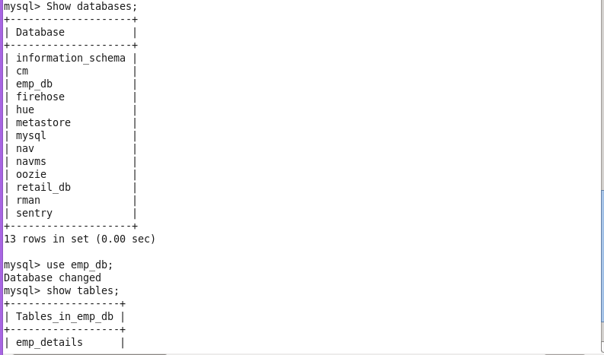

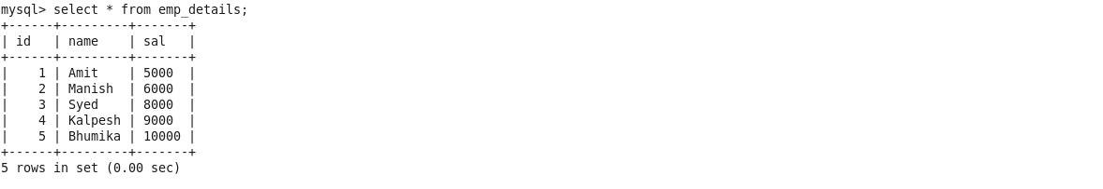

1. Now we are using sqoop import command to transfer the data from mysql to hdfs as shown below.

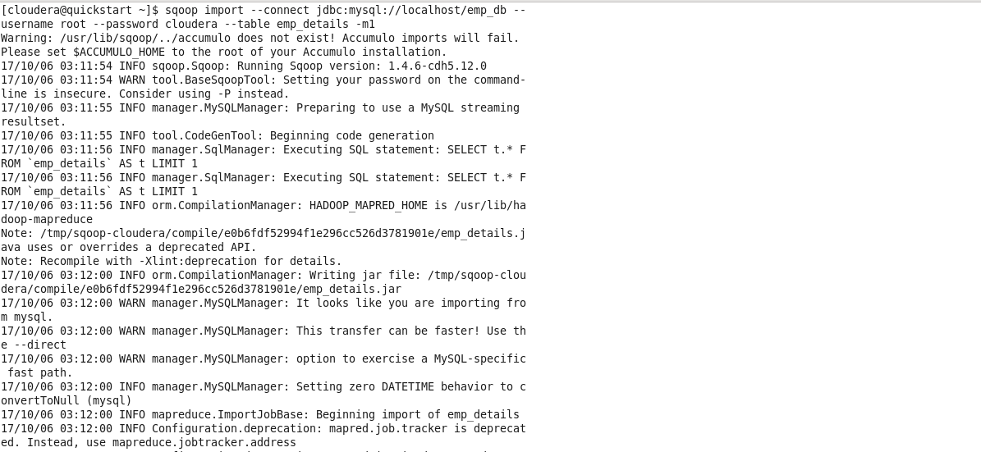

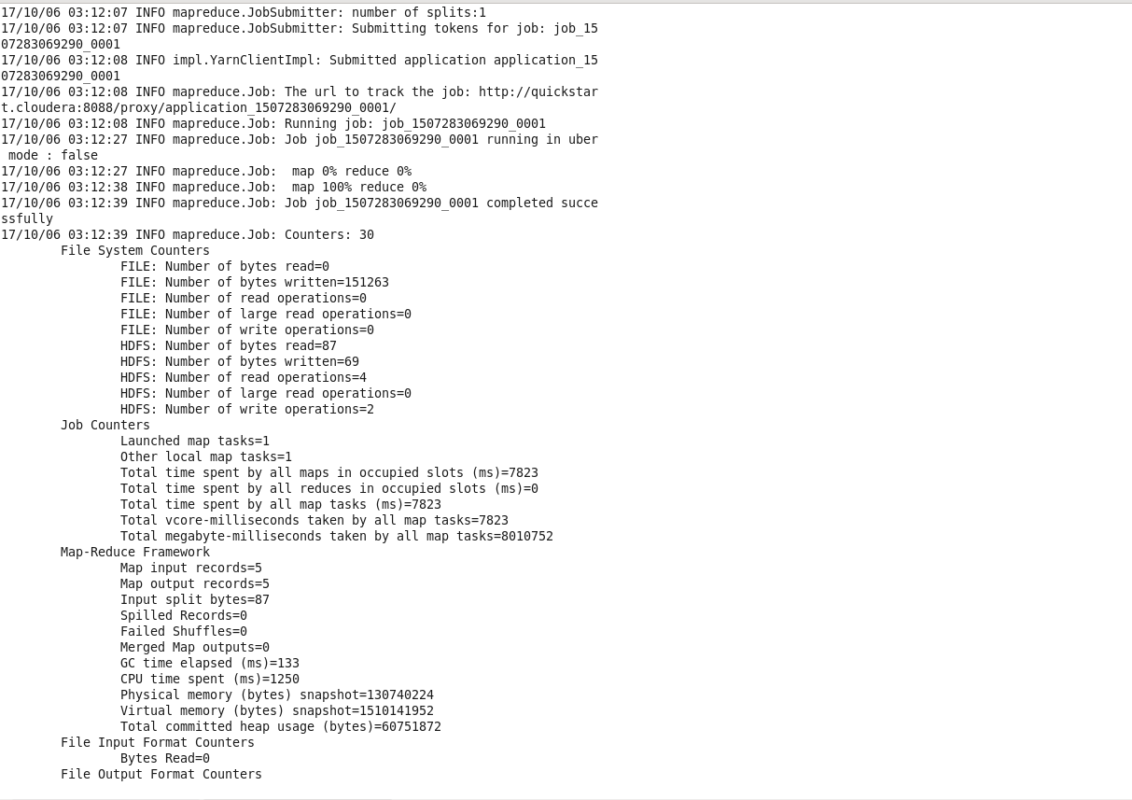

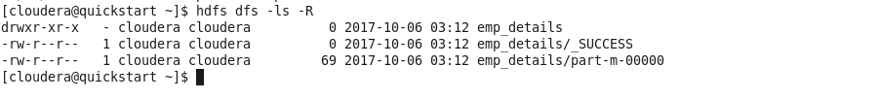

1. Now import data from HDFS to MYSQL For that we need a database and table in MYSQL and remember that schema of table should be similar to data present in HDFS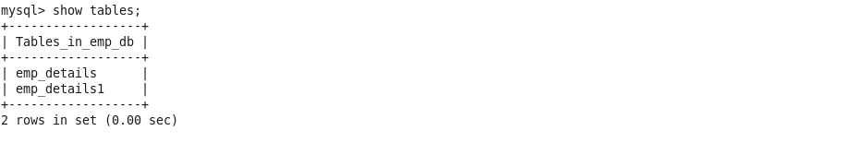

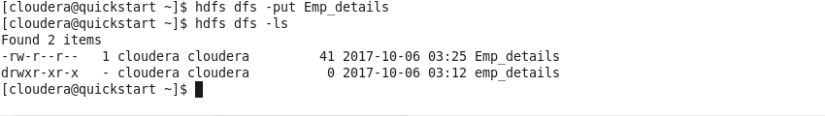

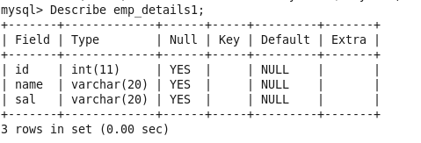

1. Now we use sqoop export command to transfer data from hdfs to mysql as shown below

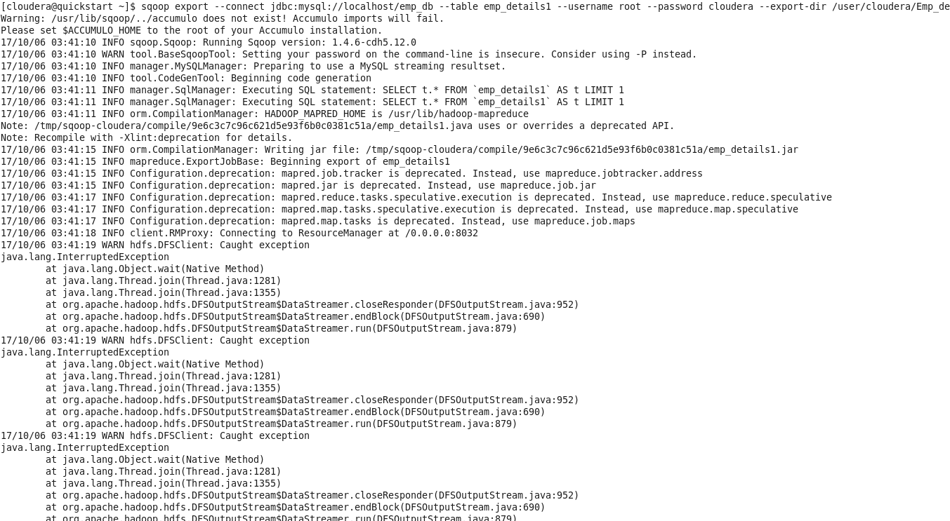

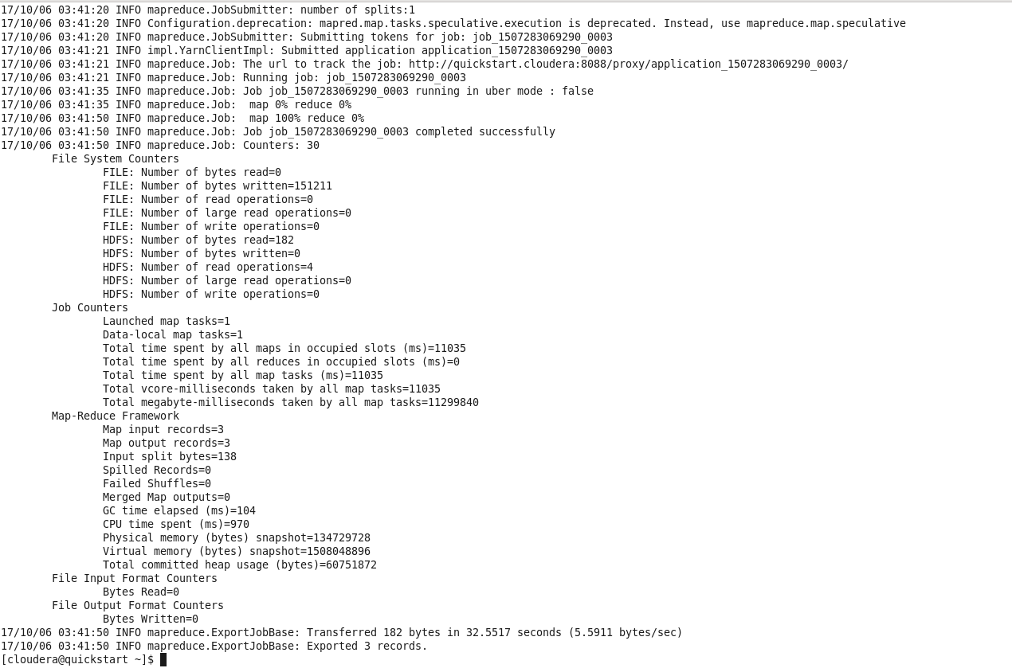

OUTPUT

